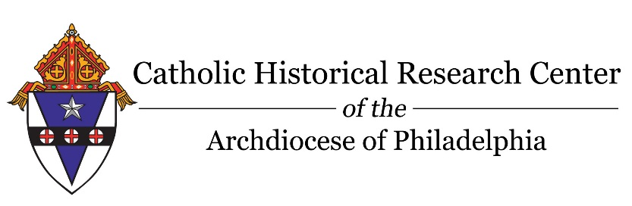

Please complete the form, along with a check or money order for $10, made out and returned to Catholic Historical Research Center, 6740 Roosevelt Blvd. Philadelphia, PA 19149.
NO FEE IS NEEDED FOR A CHURCH REQUIREMENT REQUEST
For any questions or additional information please contact CHRC at (215) 904-8149 and archives@chrc-phila.org.

REASON FOR REQUEST:
GENEALOGY MY OWN RECORDS CHURCH REQUIREMENT

TYPE OF RECORD(S) OF INTEREST:
BAPTISMAL MARRIAGE ORPHANAGE

REQUIRED INFROMATION:
NAME OF PERSON(S) BEING RESEARCHED: _______________ __________ _ _____________________________________________________ _________________________
FATHER’S FULL NAME (IF KNOWN):______________________ ______________________
MOTHER’S MAIDEN NAME (IF KNOWN): ________________________ _______________
PARISH AND/OR ADDRESS ASSOCIATED WITH PERSON(S) BEING RESEARCHED:_ _ __________________________________________________________________ _ __________
DATE(S) OF BIRTH, MARRIAGE or BURIAL (SPECIFY):________________ ____________ ____________________________________________________________________________________
ADDITIONAL INFORMATION (Please use back of form)

REQUESTED BY:
NAME: _______________________ _____ __ __________ DATE: ___________ ____
ADDRESS:____________________________________________ ________________________
CITY, STATE, ZIP:_________________________________________________ ____________
PHONE NUMBER: ___________ __ _______ E-MAIL: ________________ _____________
SIGNATURE_________________________________________ _ _________ DATE__ _

